Assignment 1 – Introduction To Software Development
CSC 300 Fall 2026
Notes: All homework must be submitted via e-mail.
E-mail address is:
csc300csudh@gmail.com
The homework file should be submitted with your name using the following format:
RosenthalH_AZ.docx, where Z is the assignment number. Note: use your name, not mine
Total Points - 107

Short answer questions.

- Describe the difference in scheduling between agile and traditional software development methodologies. (8)

- List 4 key responsibilities of a software engineer. (8)

- List and describe 10 key considerations in software engineering (30)

- List and describe 5 key practices in Software Development (15 points)

- Describe refactoring. (4)

- List 5 good coding practices for Java programmers. (10)

- Define Static Program Analysis and give 2 examples (6)

- Describe the Test Methodology For Function Testing (Look at the pdf version of the table and find the correct box) (10)

- What is cyclomatic complexity and how is it calculated? (8)

Problems:
- Cyclomatic Complexity (8 points)
Calculate the cyclomatic complexity for the following figure, assuming a single exit node. Show your formula and calculation to ensure partial credit.
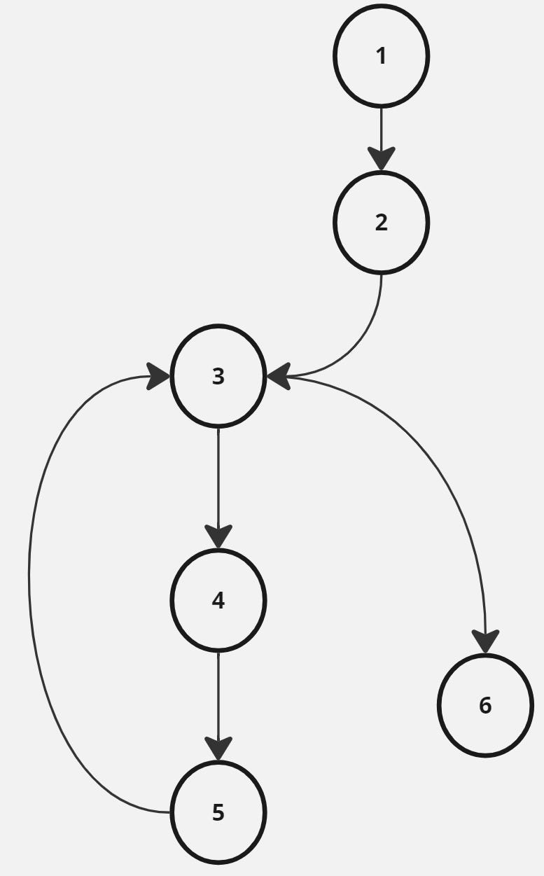

Answer:

Cyclomatic Complexity =

